**Mohammed-Mujahed batch-16 S3-Tasks**

1. Create an S3 bucket and upload some objects to S3.

  
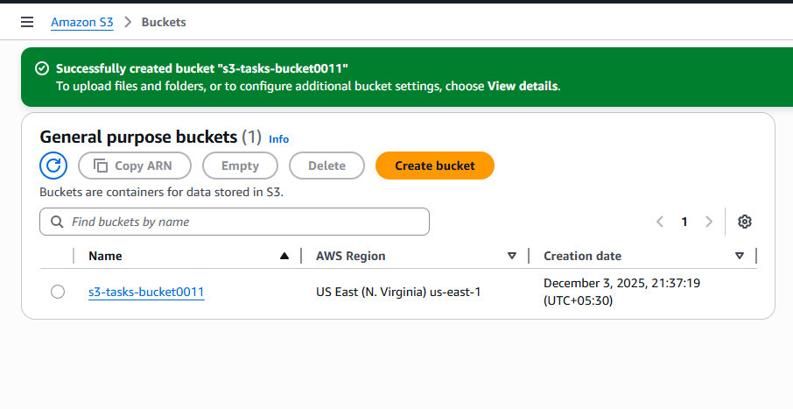  
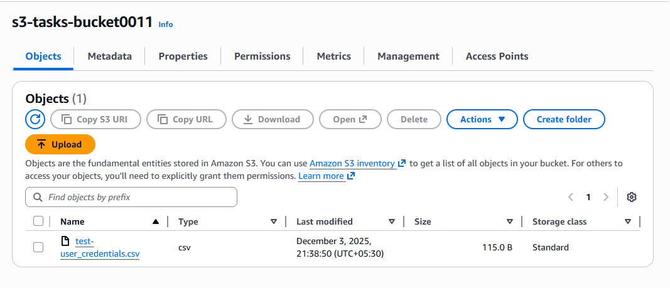  
steps: • Go to **AWS Console → S3**.

• Click **Create bucket**.

• Enter a unique bucket name.

• Choose region (example: **ap-south-1**).

• Leave all other settings default → click **Create bucket**.

• Open the bucket → Click **Upload**.

• Add files → Click **Upload**.

2:Deploy a static website in the S3 bucket.  
  
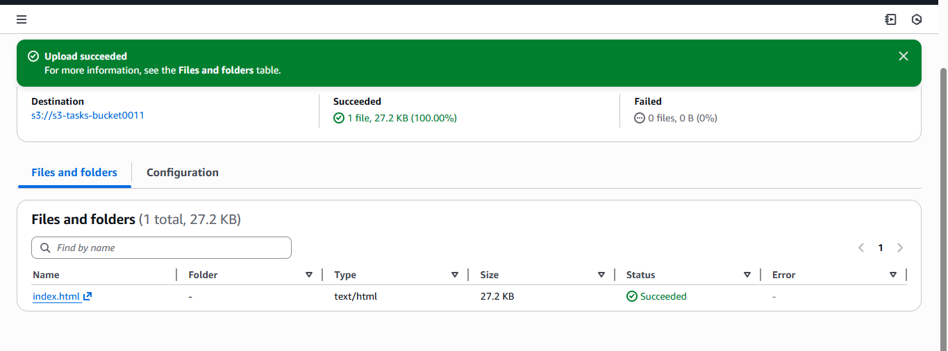  
  
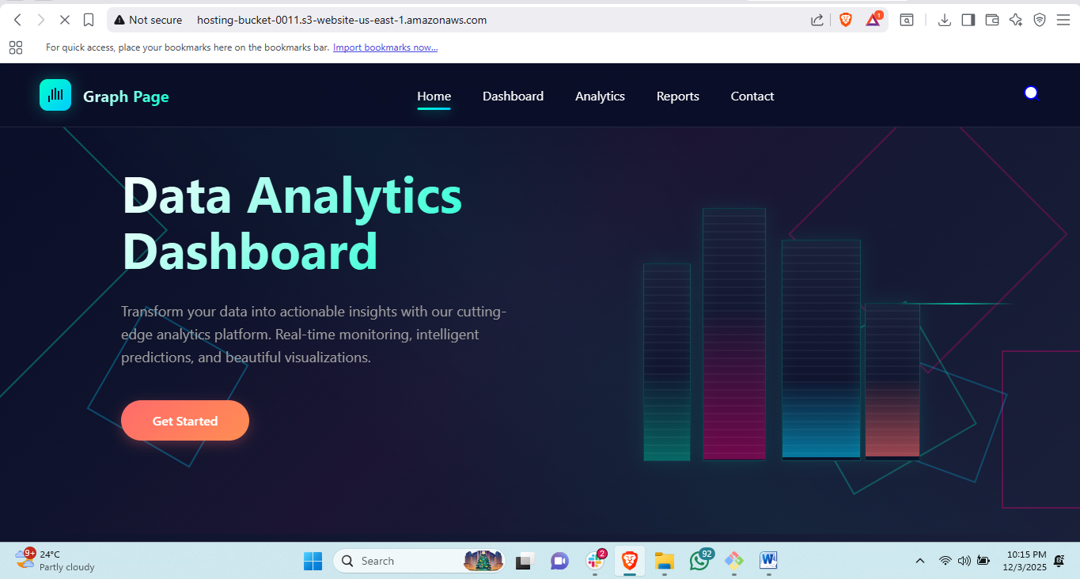  
steps: Open your S3 bucket → Go to **Properties** tab.

1. Scroll down → **Static website hosting** → Click **Edit**.
2. Choose **Enable**.
3. Enter **index.html** as Index document.
4. Click **Save changes**.
5. Upload your index.html to the bucket.
6. Make it public:
   * Go to **Permissions** → **Bucket policy**
   * Add a public read policy (console gives a ready option when enabling hosting).  
       
     if website shows 403 because you uploaded index.html.zip file so unzip this file then upload it.

3:Enable cross-region replication on S3 buckets.  
  
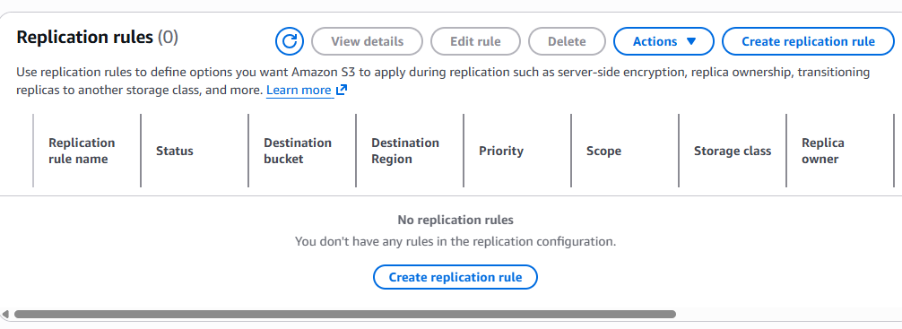  
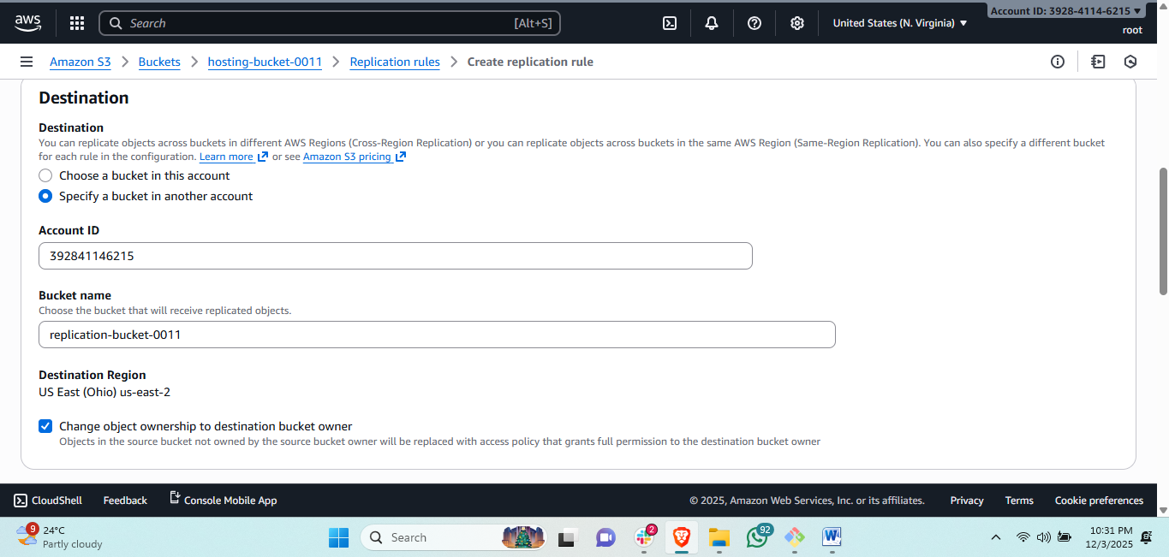  
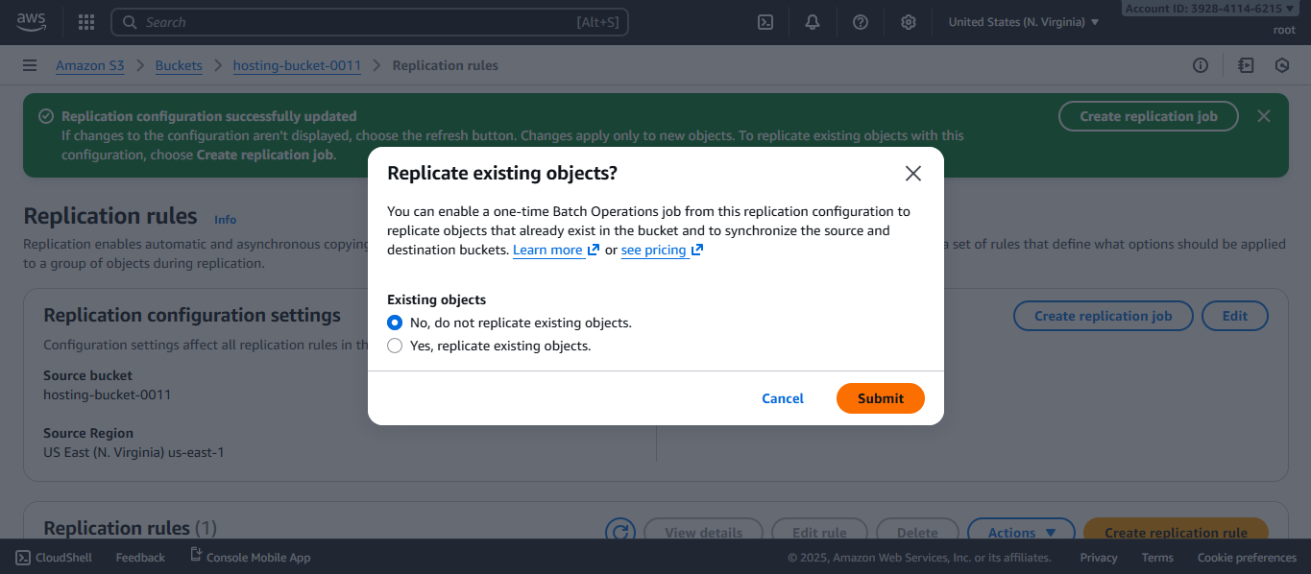  
  
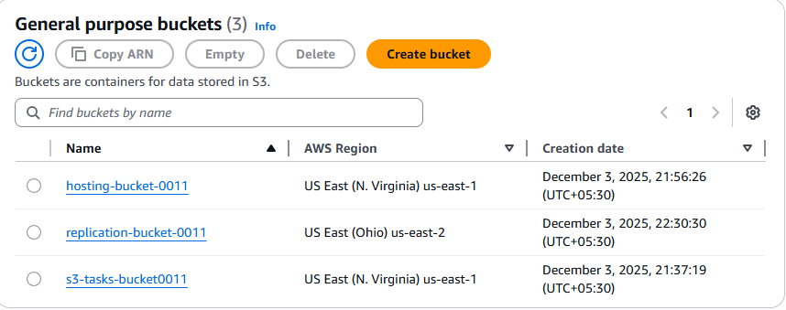  
  
steps for replication:  
**Prerequisite:** Create a **destination bucket** in another region.

1. Go to **Source bucket → Management tab**.
2. Under **Replication rules**, click **Create replication rule**.
3. Rule name: replicate-all.
4. Choose **Enable rule**.
5. **Source**: Keep entire bucket.
6. **Destination**: Select destination bucket (another region).
7. Choose **Create IAM role automatically**.
8. Save rule.

4: Configure a bucket policy so only the Admin user can see the objects of the S3 bucket.  
  
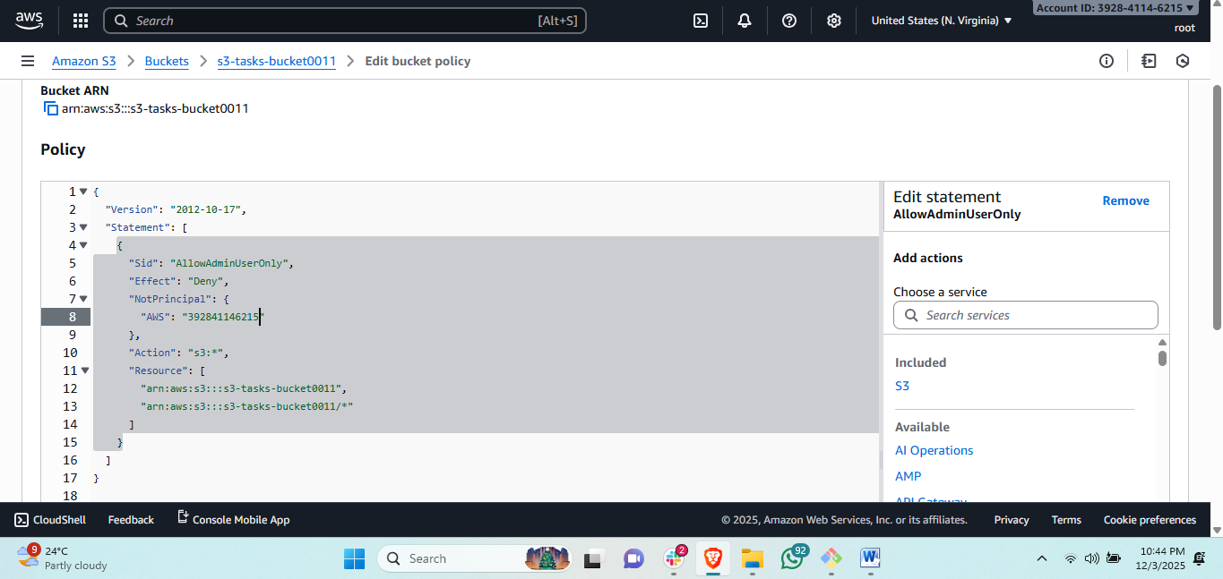  
steps: • Go to **IAM → Users** → Select your Admin user.

• Copy the **Admin User ARN**.

• Go to **S3 → Your bucket → Permissions**.

• Scroll to **Bucket policy** → Click **Edit**.

• Use this policy (replace ARN & bucket name):

1. 5:Set up lifecycle policies to automatically transition or delete objects based on specific criteria.  
     
   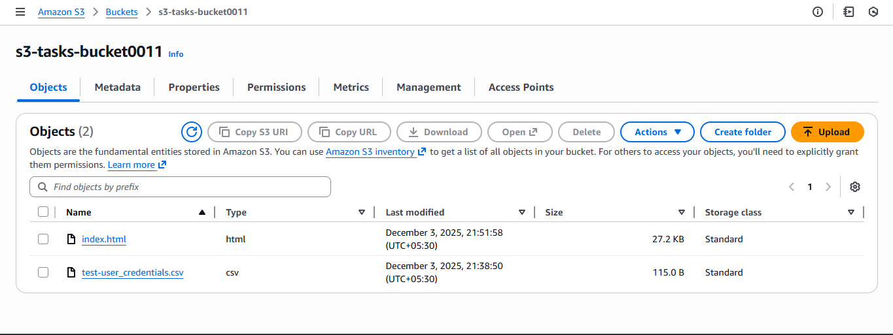  
     
   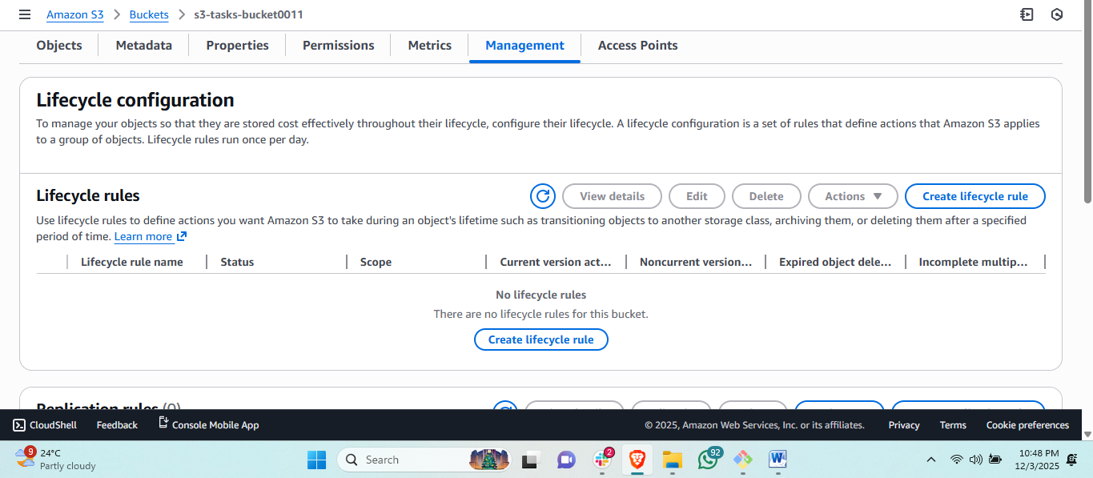  
     
   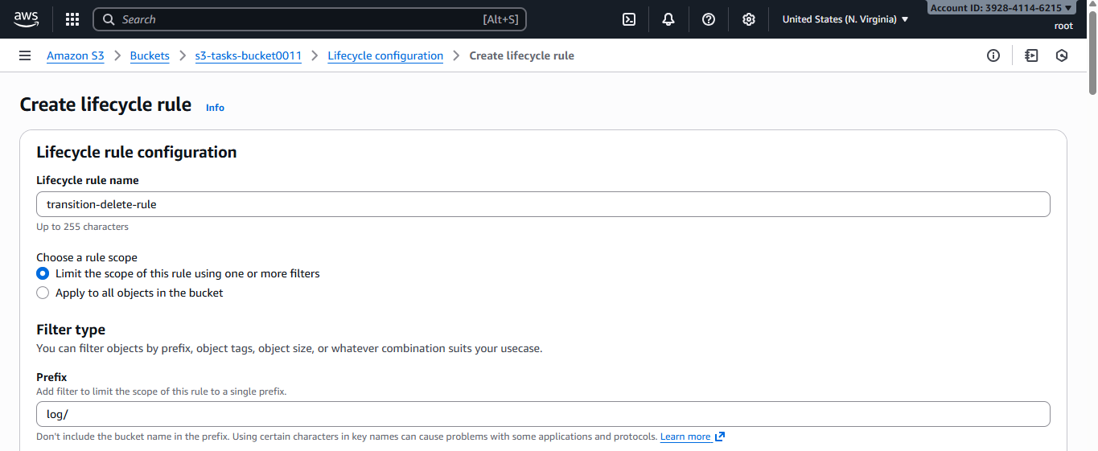  
   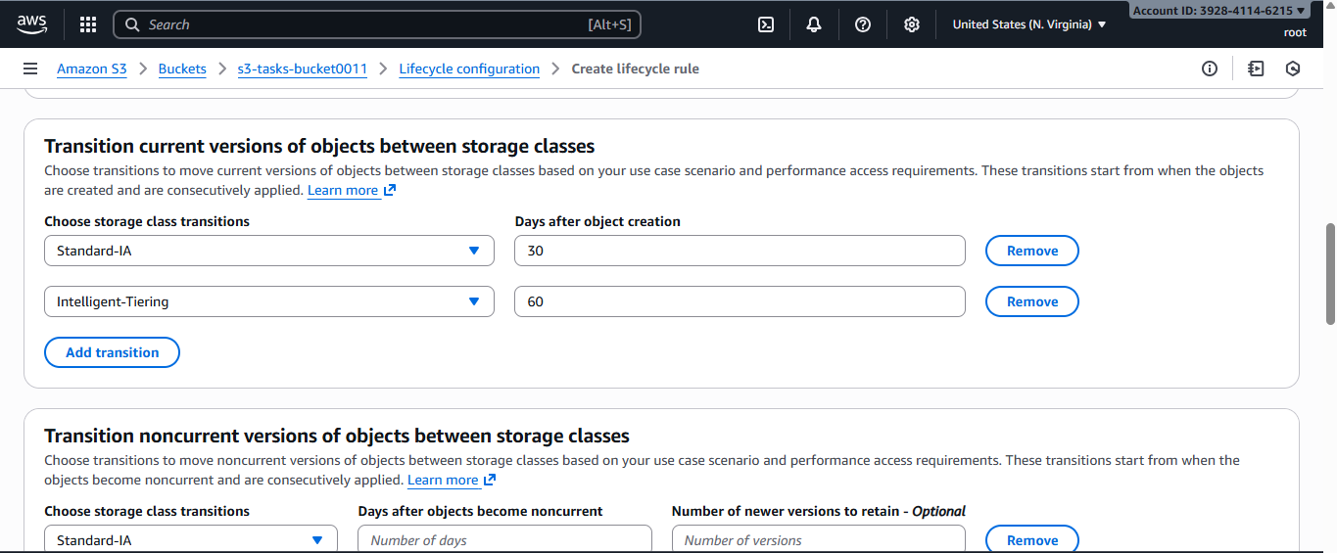  
     
     
   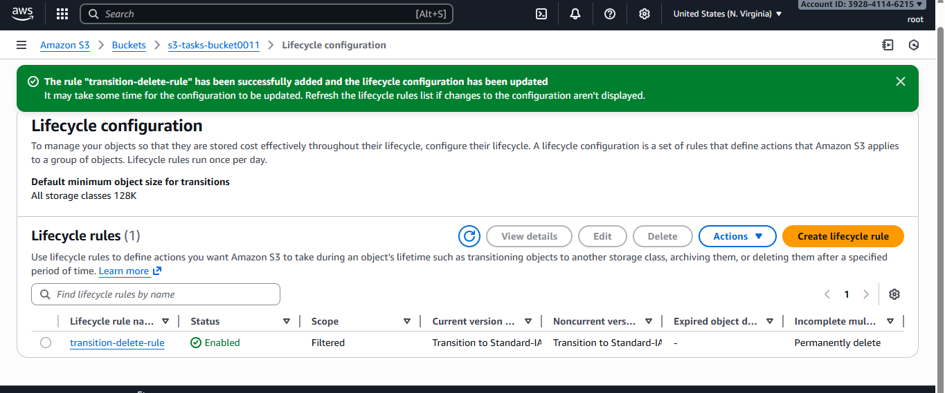  
     
   steps: Open your S3 bucket → **Management** tab.
2. Click **Create lifecycle rule**.
3. Name: transition-delete-rule.
4. Choose prefix if required (logs/, tmp/, etc.).
5. Below, choose:

### Example setup:

* **Transition to Standard-IA after 30 days**
* **Expire/delete objects after 7 days**

1. Click **Save**.

6: Push some objects to S3 using the AWS CLI.  
  
  
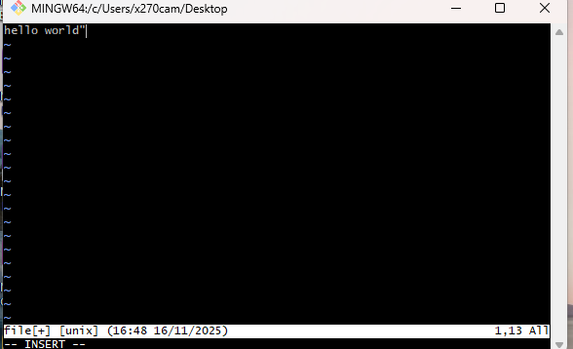  
sharing this file from local to s3 bucket using cli.  
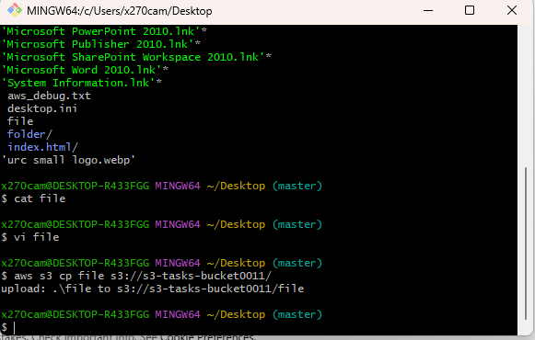  
pushed file from desktop to s3 buckets using command   
#aws s3 cp file1.txt s3:// **s3-tasks-bucket0011**/  
  
  
  
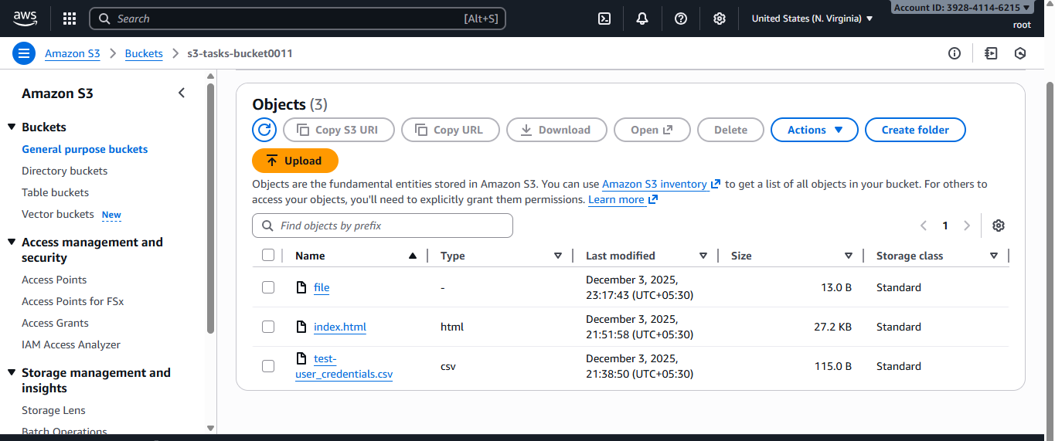  
#here you can see file is successfully uploaded by using aws cli.  
  
  
steps:

7:Write a Bash script to create an S3 bucket.  
aws s3api create-bucket \

--bucket my-cli-bucket-77801 \

--region ap-south-1 \

--create-bucket-configuration LocationConstraint=ap-south-1  
  
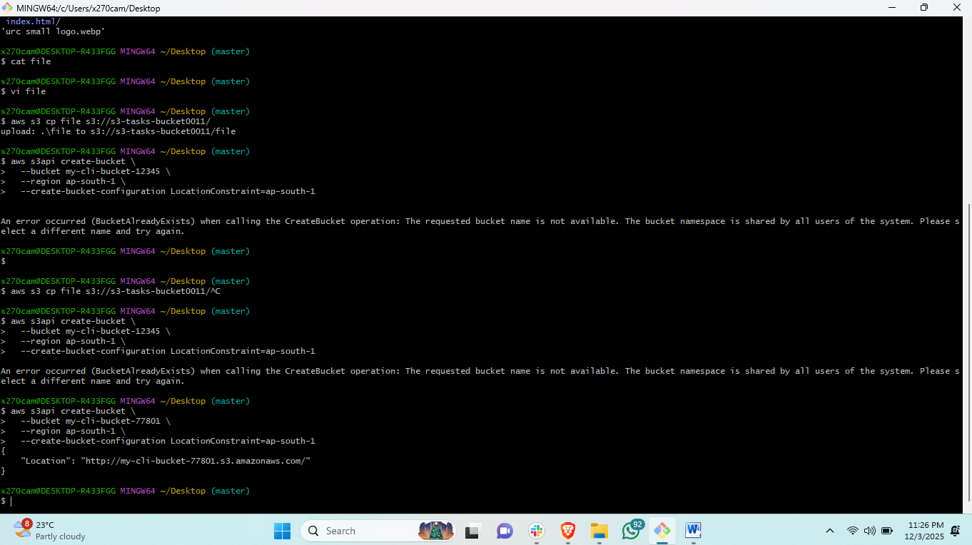

8::Upload a 1 GB file to S3 using the CLI.  
  
purpose: to share and upload your object to your s3 bucket through the cli <command line interface>  
  
steps: first see where your object is available  
>then open git bash and configure aws <aws configure>  
>command to share file from local to s3.<aws s3 cp filename s3://bucket-name --recursive.  
>se use recursive if we have a folder to upload.  
  
  
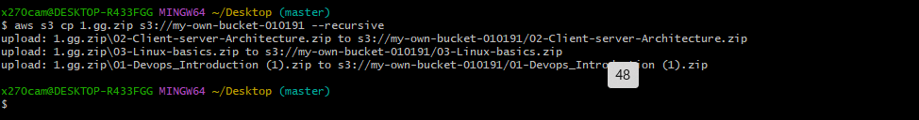  
  
  
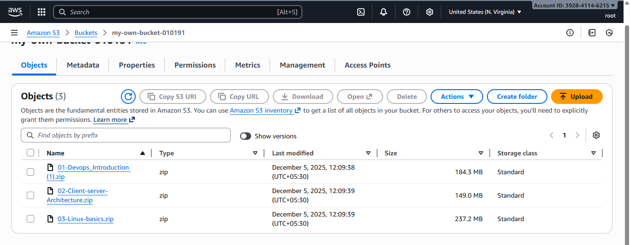  
  
here you can see the result the file is imported successfully.